The recent decline in college-going among Black Americans[1].

Juliana de Castro Galvao, Samuel Neylon, Christopher Maggio and Paul Attewell.

Graduate Center of the City University of New York. 11/10/2019

**Introduction[2].**

Black enrollment in higher education grew steadily throughout the second half of the 20th century and continued to expand until 2010, a driving force behind the growth of the Black middle class (Landry 1987, 2018). After 2010, however, this long upward trend reversed. As we document below, the number of Black undergraduates enrolling in college has fallen year after year since 2010 and is now 9% below its peak (a decline of about 202,000 Black students), too large and too sustained a decline to be dismissed as a temporary blip. This paper investigates why the number of Black students enrolling in college has fallen and considers whether this trend threatens the economic future of the Black community.

We draw upon multiple data sources to identify the underlying causes of this shortfall, first asking whether demographic trends – the number of Black children born each year – account for the shrinkage. We then investigate whether the decrease results from a drop in high school graduation rates, or in the proportion of Black graduates proceeding immediately from high school into college, or whether shrinking college enrollments reflect higher drop-out rates among Black students already in college. We also compare different sectors of higher education, to see whether enrollment declines have occurred across the board or are concentrated in for-profit colleges, or at public community colleges, or at historically Black colleges and universities (HBCUs). Finally, we consider whether shrinking enrollments might have a silver lining: Has a booming economy generated enough jobs that more Black Americans are being drawn into the labor market instead of to college?

The first section of this paper provides a sketch of the current educational circumstances of the Black community as a whole, summarizing the research literature on that topic, in order to provide a broader context for a following section focused on the recent reversal in enrollments.

**Context & Prior Literature:**

Figure One is reproduced from a recent government report by de Brey et al (2019) and portrays the level of educational attainment for racial/ethnic groups in the United States, for persons age 25 or older, based on data from the US Census’ American Community Survey of 2016.

One important feature is the large proportion of Black adults (25%) who have attended college but without completing a degree at either the associates or the bachelor’s level. Government statistical agencies refer to this group as having “some college,” a category that includes some individuals who receive a short-term credential (but less than an associate degree) combined with those in degree tracks who left college with no credential whatsoever.

Figure One: Educational Attainment of US adults age 25 and older by race and ethnicity, 2016.

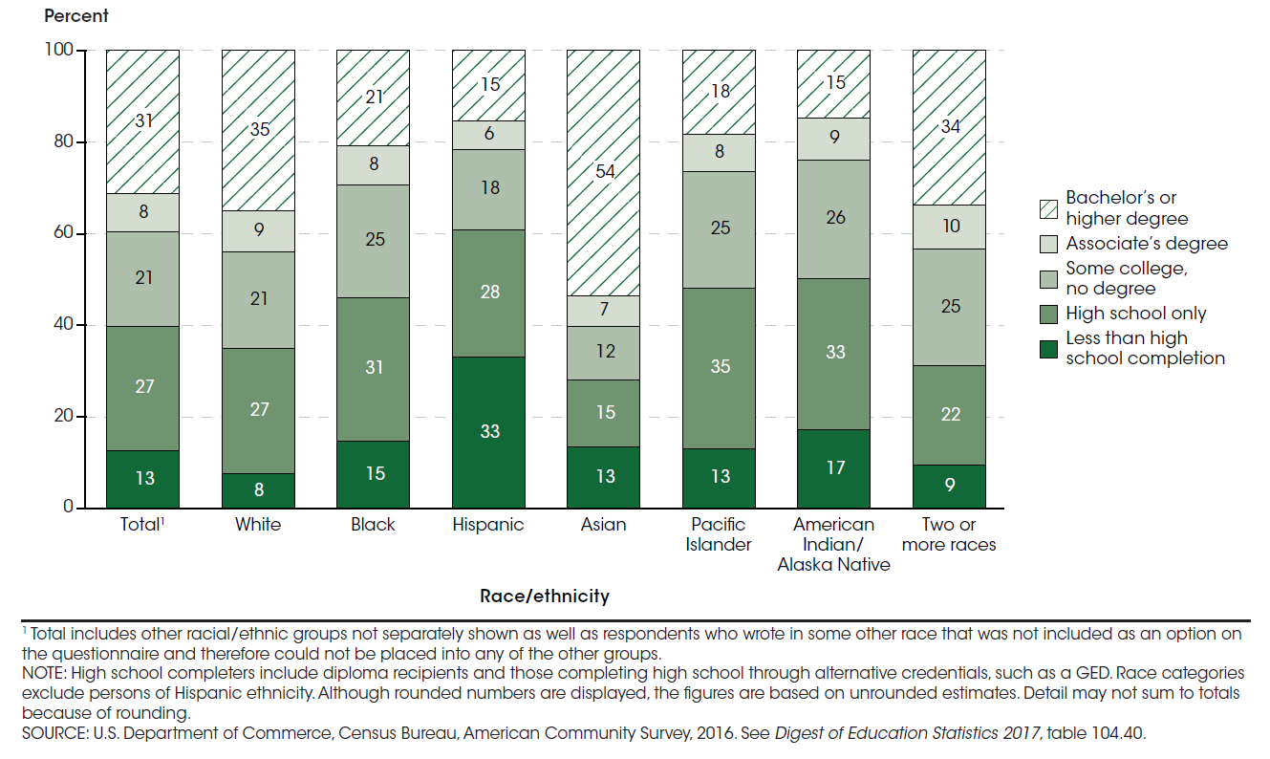

Scholars disagree whether attending college without completing a credential represents an economic step upward, compared to leaving education immediately after graduating high school, or whether incomplete college implies a waste of the student’s time and money. Our own research (Giani et al 2019) has shown that Black Americans with some college but no credential are much more likely to find employment years later compared to high school graduates who never went on to college. Once employed, “some college” individuals earn significantly more than high school graduates who never attended college at all. In other words, in our judgement, attending college does “pay off” even for those who do not complete a credential. But it is also clear that completing a degree – whether an Associates or a BA – pays off more than only “some college,” so the unusually large proportion of Black college-goers who do not complete a degree is still a matter of policy concern.

Why do so many young people – of all races, but Black students disproportionately – fail to complete college? Researchers point to several causes (Attewell et al 2011, Braxton 2000, Chen et al 2019, Radford et al 2018 Table 13 p.22). College-goers who were not academically-oriented, who received poor grades and lacked more advanced courses while in high school are much more likely to drop out when they attend college. Nevertheless, most dropping out from college is not due to academic failure. Decades ago, Tinto (1993) estimated that somewhere between 15% and 25% of undergraduates quit college because of academic difficulties. In the most recent data, about 24% of drop-outs still cite academic difficulties as their reason for leaving college (Radford et al 2018). So that problem has neither improved nor gotten worse over time.

Many students who come from lower-income families drop out of college even though they are *not* having academic difficulties: about 46% of recent Black college leavers cite financial stresses as their motivation for quitting college, compared to 35% of White college leavers (Radford et al 2018). There is a burgeoning literature on the economic stresses experienced by students (US GAO 2018). Undergraduates often juggle competing obligations: some are parents, others support their own parents and siblings in financial and/or emotional ways. A larger proportion of Black college leavers (56%) cite family and personal reasons for dropping out, compared to Whites (48%) (Radford et al 2018). In addition, the majority of undergraduates hold paid jobs while in college and it is often difficult to balance paid work hours with class attendance and studying, although recent research suggests that accumulating paid work experience while in college pays off in higher wages after students leave college (Douglas and Attewell 2019).

Taken together, financial, family, work and academic difficulties result in far lower degree completion rates among Black undergraduates than among Whites. At four-year colleges, 64% of Whites graduate within six years, while only 40% of Black students at those colleges complete a bachelor’s degree in that time frame (de Brey et al 2019 p.138).

Attending a local community college is almost always cheaper than attending a four-year college: tuition and fees are lower, and most two-year college students live at home and commute, avoiding the considerable cost of a dorm room[3]. Consequently, about 43% of Black undergraduates attend a two-year college. Unfortunately, the community college route to a degree is also a hazardous one. Completion rates at public two-year colleges are very low: among Black students who start their college career there, only 38% obtain a certificate or an associate or a bachelor’s degree within six years; the remaining 62% earn no credential (Chen et al 2019: Table 2).

Most students entering community college aspire to a bachelor’s degree, but few get that far, in part because most do not manage to transfer to a four-year college. Those who do transfer frequently find that the new institution does not fully recognize the credits they accumulated at the community college, so they have to take extra courses to make up for those lost credits (Monaghan and Attewell 2015). Even if they do make it all the way to a bachelor’s degree, individuals who started at a community college earn significantly less in later years than counterparts who began at a four-year college (Witteveen and Attewell 2019a.)

Two other issues are important to mention about the current educational context for Black Americans. Over the last two decades Black students have entered for-profit colleges in large numbers (Cotton 2017, Ruch 2001). Our analyses of government data show that 10.5% of Black undergraduate men and 12% of Black undergraduate women enrolled in for-profit colleges in 2010. Research suggests that graduation rates at for-profit colleges are about the same as at public colleges, for students of equivalent backgrounds (Deming et al 2012). But all evidence indicates that students at the for-profits pay a lot more in tuition and fees than their counterparts who attend public colleges. The vast majority of students at for-profit colleges pay by taking out student loans; the for-profit sector loads debt upon its students (Dynarski and Kriesman 2013). It comes as no surprise therefore that default rates are especially high for those institutions. Black non-completers who attended for-profit colleges have the worst loan repayment records of all (Scott-Clayton 2018, Witteveen and Attewell 2019b).

A second issue concerns the extent to which Black students find predominantly-White colleges to be unsupportive or unwelcoming, and whether this might account for the lower retention and graduation rates of Black collegians, rather than or in addition to issues of academic preparation, financial stresses, and family obligations. This possibility is sometimes raised by advocates of HBCUs, who view majority Black colleges as culturally more supportive and caring places for their students.

Prior research speaks to this but reaches a complicated conclusion. Studies of Black and low-income students at highly-selective predominantly-White institutions report that many such students have to study extremely hard to keep up and often find college a very stressful and joyless experience (Arcidiacono et. al. 2016, Aries 2008, Byrd 2017, Goodwin and Weiss 2006, Jack 2019, Lee 2016). Minority and low-income freshmen are often shocked to find that even though they were outstanding students at their high schools, their academic skills at college entry are considerably below those of White classmates who attended more affluent schools.

In addition, staff and administrators at more elite four-year colleges are often quite insensitive to the challenges that low-income Black students face. They don’t understand when scholarship students cannot afford to go home during breaks between semesters, or the financial binds that some first-generation students face because they are sending money home, or the stresses that students face when they need to work long hours for pay (Jack 2019). Add to this, racist comments and stereotyping that Black students sometimes face from White classmates. Taken together this might suggest that most Black students would do much better attending predominantly Black colleges.

But they don’t. While HBCUs offer a supportive and culturally-sensitive environment to most of their students and consequently generate great loyalty among many alumni, HBCUs don’t escape the problems of high student dropout rates or low graduation rates (Nichols and Evans-Bell 2017, Smith-Barrow 2019). Researchers disagree over whether graduation rates at HBCUs are worse or somewhat better than at public colleges – the picture changes depending on how one adjusts the numbers to account for students’ socio-economic backgrounds (Allen 1992, Franke and DeAngelo 2018, Kim and Conrad 2006, Nichols and Evans-Bell 2017). But no one claims that the degree completion problem has been solved at HBCUs: Nichols and Evans-Bell (2017) report a 32.1% graduation rate within six years at HBCUs, for example. Beyond this, HBCUs currently educate about 9% of all Black undergraduates[4], so while they are very important producers of graduates who will join the Black professional and middle classes (Natheson et al 2019) they educate a relatively small proportion of the total Black undergraduate population. In addition to financial stresses (Smith-Barrow 2019) HBCUs are also facing declining enrollments, as we will document below.

With this overview as context, we will now focus our inquiry on the changes in Black college enrollment since its peak in 2010.

*Changing Birth Rates.*

Birth rates in the US have been declining in recent years, both among African American women and among non-Hispanic White women, drops that are reflected years later in fewer numbers of college-age individuals. Figure Two illustrates the decline in the number of Black 19-year-olds, from a high in 2010 to the present. These data, from the US Census’ estimates, include 19-year-old Black immigrants as well as US-born Black 19-year-olds.

There were about 79,000 fewer Black nineteen-year-olds in 2015 than there were in 2010, the high point. Since 2015 those numbers have increased slightly, so the shortfall is now about 72,000. Since we know how many babies were born last year, we can also look forward and anticipate how many Black nineteen-year-olds there will be in the near future. They suggest a roughly stable number of Black youths, around the current lower level. going forward. However, one source of uncertainty about future numbers stems from Black immigration into the United States. Black immigration of families with children has been and will continue to contribute substantially to the number of Black college-goers in the years ahead (Hamilton 2019, Robinson 2010).

Although the demographic figures do show a decline in the size of the college-age cohort since 2010, the decrease is not large enough to account for the recent drop-off in Black college enrollments, which is nearly three times larger. We therefore need to look more deeply at the numbers of high school graduates, and determine whether they are heading to college or into the labor force, and whether college entrants are persisting or dropping out.

Figure Two.

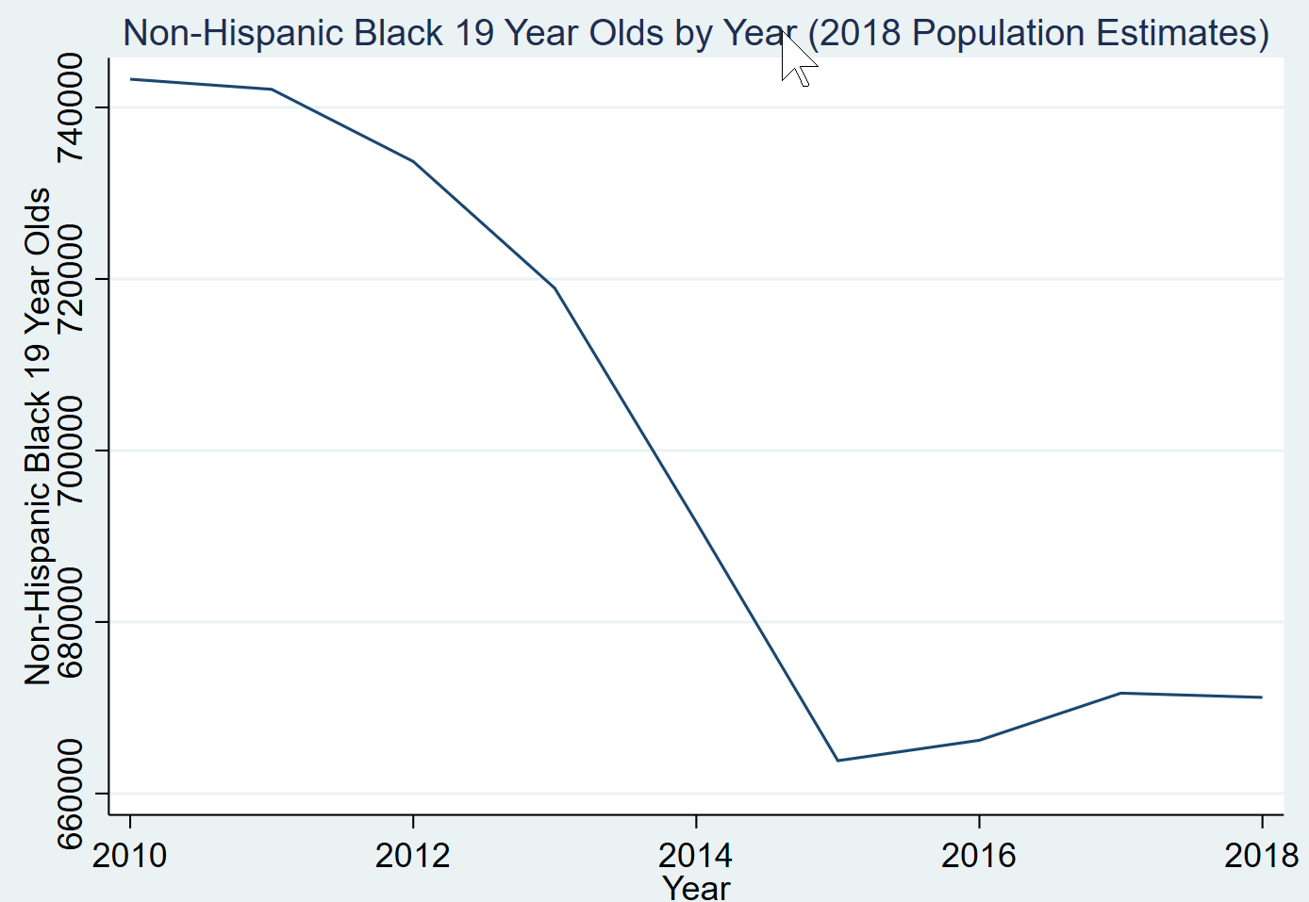

*Changing Black Incarceration Rates.*

As a side note, the decline in numbers of Black undergraduates since 2010 is certainly not due to incarceration levels. Although the incarceration rates of Black men and women are much higher than for other racial and ethnic groups, the number of incarcerated persons has been decreasing for most of the last two decades. Black male incarceration levels reached their peak in 2001 and have since declined by a third. Black women incarceration numbers have dropped by 57% from their peak in 1999 to the latest 2017 numbers (Bronson and Carson 2019. Lane and Humphreys 2019). Other things being equal, declining numbers of Black men and women in prison might potentially lead to increasing numbers of Black men and women college-goers. A decline in incarceration could not plausibly create the drop in the number of Black college enrollments that we have experienced since 2010.

*Changing High School Graduation Rates*

For several decades, educators, policy makers, and community leaders have been urging minority youths to “stay in school.” Their efforts have been modestly successful, and the high school graduation rate – measured as the proportion of Black 18-to-24 year-olds who have graduated from high school – has increased from 89% in 2010 to 93% in 2017 *[5]*. This success story applies both to young Black men and to young Black women, and it increases the pool of Black youth who are qualified to go on to college and therefore offsets to some degree the recent demographic decline in the size of the Black youth cohort. Why then are Black college enrollments declining?

*Immediate Transition from High School to College.*

The first clue is to be found in government figures about the proportion of high school graduates who enter college in the year immediately after high school graduation. There has been a quite rapid drop in the proportion of Black high school graduates enrolling in college in the year following high school, from 66% in 2010 to 56.5% in 2016 (the latest figure available).[6]

This roughly ten percentage-point decline in the immediate transition to college raises the question as to what these high school graduates are doing instead. The most plausible answer is that the economic recovery in the years after the 2007/8 recession and the recent economic expansion have greatly improved employment prospects for Black youth and led some who might otherwise have continued into college to take jobs instead.

The evidence for this is indirect, and is presented in Figure Three. We focus initially on a group of young people that demographers refer to as NEETs, which stands for “Neither in Employment nor Education nor Training.” NEETs are young people who are disconnected from the worlds of work and education. The changing numbers of Black NEETs – in Figure Three below -- provide a window into how the economy is affecting a very economically-vulnerable part of the community.

Black youth ages 20 to 24 who have not completed high school are the least likely to go to college or to find employment. About 65% of this group were NEETs in 2010. But by 2016, only 54% of Black high school non-completers in this age group had NEET status, a ten percentage-point reduction in six years. They have been able to find employment.

Some Black youth who have successfully graduated from high school also do not find jobs or continue in education, although they are much less likely to enter NEET status than their counterparts who did not graduate high school. Nevertheless, about one-quarter of Black high school graduates aged 20 to 24 were NEETs in 2010. Again, their numbers have dropped considerably in the six years since 2010, to 19.5%. This recent drop in the proportion of Black youths who are NEETS is evident both for men and for women.

Figure Three.

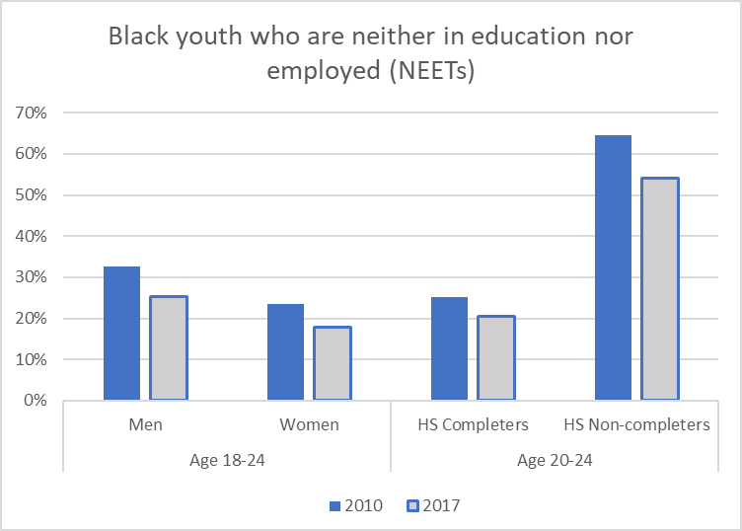

*Source: Digest of Education Statistics (2018 eds.), Table 501.30* Retrieved from: <https://nces.ed.gov/programs/digest/d18/tables/dt18_501.30.asp>

Every 2017 figure is statistically significantly lower than the corresponding 2010 number.

The fact that fewer individuals than previously are unable to find employment or go to school is a strong hint that a buoyant economy is drawing economically vulnerable young people into employment. By implication, we might expect similar increases in employment opportunities to draw some students away from college, which we examine next.

*Changing Enrollments across College Sectors.*

Table One presents our analyses of college enrollment, using data collected from over 4000 individual colleges by the US Department of Education, in a reporting system known as the Integrated Postsecondary Data System (or IPEDS). IPEDS covers all colleges nationwide that are covered by Title IV and whose students are therefore eligible for federal funding.

The left-hand side of Table One reports Fall enrollment numbers for all undergraduates (from freshmen to seniors) and separately for Black undergraduates for the period 2010 to 2017. The right-hand side reports similar numbers but for first-time undergraduates.

Looking first at the left-hand panel, we see that Black enrollments as a whole have dropped by 8.8% (by about 202,000 students) compared to a 2% decline for undergraduates of all races.

This overall shrinkage in undergraduate numbers combines two opposite trends. At four-year public colleges and universities—the largest sector in higher education with about 7.5 million undergraduates – enrollments *grew* substantially between 2010 and 2017. Total (all race) enrollment in the four-year public sector increased by 15% (nearly one million extra undergraduates) in this period, while Black enrollments at public four-year colleges also increased but not by as much (by 8%, or about 62,000 students).

Over the same period, enrollments dropped dramatically in the second largest sector of higher education: the two-year public colleges (community colleges). Their total enrollments shrank by 1.3 million students, about 19% of their 2010 enrollments. In proportional terms, the loss of Black enrollment from community colleges was even larger: a 24% reduction.

Other smaller sectors experienced even more drastic shifts in enrollment during those seven years. The for-profit two-year sector has faced a huge enrollment reduction of 39%, and the for-profit four-year colleges have similarly lost 16% of their enrollment.

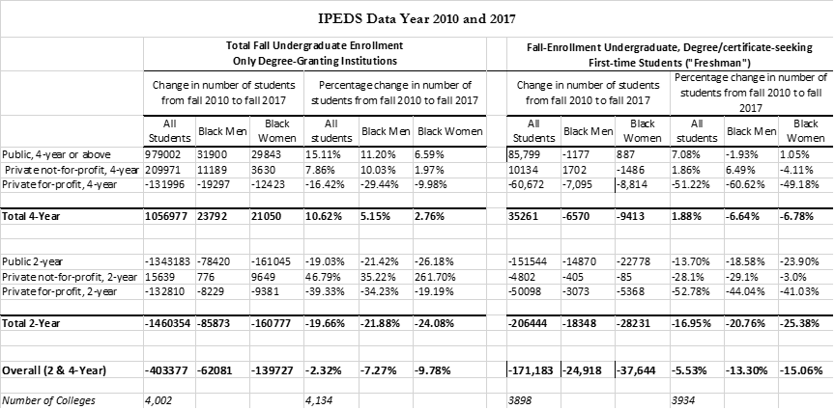 Table One.



Table Two.

In sum, Black undergraduate enrollment has dropped overall: roughly 202,000 fewer Black undergraduates were in college in 2017 compared to 2010. But among the generation who did attend college in 2017, there has been a modest shift towards four-year colleges (about 8% more Black students), in both public and non-profit baccalaureate institutions, compared to the earlier cohort in 2010.

These numbers do not imply that individual students have left certain types of institutions and have enrolled in others instead. The enrollment numbers refer to two different time periods. A better way to think about these figures is that in 2017 fewer people are going to college overall than was the case in 2010, and that the kinds of colleges where the current generation is enrolled differ from those that their counterparts (older sisters and brothers, perhaps) attended in 2010.

There is a gendered aspect to some of these changes. The enrollment drops at two-year for-profit colleges between 2010 and 2017 were disproportionately among Black men, compared to Black women, although both have markedly lower numbers in those institutions compared to 2010.

We had wondered whether the decline in college enrollments might vary across the age spectrum, but that seems not to be the case. Overall, enrollments in four-year colleges are up and those in two-year colleges are down for all age groups since 2011. The only unusual pattern is that in both the two-year and the four-year sectors there has been a substantial uptick in the numbers of students who are younger than 18. In the four-year sector, under-eighteens have jumped from 493,665 to 753,688, while in the two-year sector, which has been shrinking overall, the numbers of under-eighteen year-olds have also jumped, from 293,112 to 480,321. These are large increases percentagewise, but since these young students only constitute a very small proportion of undergraduate enrollment as a whole, they barely affect the larger picture. We suspect that the increase in under-18s represents the growing popularity of “dual enrollment” – taking one or more college courses while still enrolled in high school. Unfortunately, the IPEDS numbers don’t allow us to check on that possibility.

The right-hand side of Table One provides a different perspective on changing enrollments that is limited to incoming first-time students. It shows that the enrollment decline for first-time students is even larger for than for students as a whole. There are again large decreases in enrollments in the two-year sector, and in for-profit colleges (both two and four year). One difference is that while total enrollment figures for Black men at four-year public colleges have increased between 2010 and 2017, they have *decreased* a little (by about 2%) for first time Black male students. The number of Black women first time students attending public four-year colleges has increased by about 1%.

Table Two presents similar data on enrollment changes between Fall 2010 and Fall 2017 in the number of Black men and women undergraduates at Historically Black Colleges and Universities (HBCUs). The overall enrollment shrinkage at the HBCUs was 24,195. The number of Black men enrolled decreased by 18% between 2010 and 2017, and the number of Black women decreased by 12.7%. By 2017, Black students constituted 80% of total enrollment at the HBCUs.

In summary, national enrollment data show a substantial decrease in the numbers of undergraduates between 2010 and 2017. This decrease has been more dramatic among Black students than among undergraduates as a whole, but is evident for both Black and non-Hispanic White undergraduates. The enrollment decline has been greatest in the two-year sector, where both public community colleges and the for-profit two-year colleges have experienced large drops in Black enrollment. In contrast, there has been enrollment growth in these years at the four-year colleges, including growth in numbers of Black students at those institutions, although in percentage terms Black growth at four-year colleges has not been as strong as for other racial groups. Looking at first-time undergraduates separately, the picture also shows strong declines in two-year enrollments between 2010 and 2017, but a decline of almost 7% in the numbers of Black first-time undergraduates entering four-year institutions.

**Discussion & Conclusion.**

For half a century the economic progress of Black Americans has been closely tied to improvements in educational opportunity, and especially in access to higher education. College-going has been central to the growth of the Black middle class. For that reason, government data that indicate recent declines in the numbers and percentage of Black youth enrolling in higher education have sounded alarms among community members, educators, and researchers. Undergraduate enrollments have dropped by 7% among Black men and by nearly 10% among Black women over the last seven years. This does not seem to be a temporary aberration; on the contrary the trend has intensified over the last seven years.

Only a small part of this trend can be attributed to population changes reflecting Black birth rates. Nor is the source of this shortfall to be found in the k-12 schooling system. On the contrary, high school graduation rates have improved over this period. Instead, we have documented a marked decrease in the proportion of Black high school graduates who are going on to college immediately after high school, as well as shrinkages among the numbers of already-enrolled Black undergraduates.

Some of this seems to be a response to improving employment prospects for Black youth as the national economy has emerged from the long recession following 2007/8. We can tell that the most economically-disadvantaged group among Black youth – those who did not graduate high school or find employment – has shrunk in size since 2010. More of them are now employed. Similarly, fewer Black high school graduates are without work today than in 2010. It therefore seems plausible that some of the decline in college enrollment is due to individuals who might otherwise have gone to college choosing employment instead.

That inference is strengthened by data that show that the drops in college enrollments have been largest at public community colleges and most especially in the for-profit college sector. To some extent, this decline in Black college-going may have a silver lining. If those who were least likely to complete a credential are instead finding gainful employment immediately after high school, that may not be a bad thing. If college-bound Black Americans are increasingly gaining entry into four-year bachelors-granting colleges rather than entering two-year colleges that is also probably a good thing: most will earn considerably more in the long run if they make it all the way to the bachelor’s degree.

An unresolved question is whether those Black youths who choose to go directly into jobs after high school are helping or harming their long-term mobility prospects. If they do finally go to college after spending a few years in the labor force, some evidence suggests that might not be bad for their long-term mobility. We re-analyzed national data on intergenerational mobility from the Equality of Opportunity Project (Chetty et al 2017) that tracked people born between 1980 and 1982 until they were in their early thirties. About 12% of those age cohorts delayed entry into college until they were between 23 and 29 years old. Many of those delayed students (27%) came from low-income families: those with family incomes in the bottom fifth of the national population. Remarkably 39% of the delayed undergraduates from those low-income families had risen into the middle to top income quintiles by their early thirties. In other words, evidence from an earlier generation suggests that delaying entry to college until one’s twenties does not necessarily harm social mobility in the longer run[7]. If a similar dynamic occurs for the current cohorts of Black high school graduates who are not proceeding immediately to college, then the delay would not be a cause for alarm.

However, if the Black high school graduates who go into employment rather than college are not just delaying college but will never go to college, the consequences may be different. Again, our re-analyses of the data indicate that 30% of youth from low-income families who never went to college were able to rise to middle incomes by their thirties.

A few years will need to pass before researchers will be able to tell with greater certainty whether and how the current shift in Black college-going has impacted long term social mobility in the Black community. What seems clear at this point is that a sea change has been underway for most of the last decade in college going among Black Americans, implying that community leaders, policy makers and researchers should pay close attention to this change.

**References**

Allen, Walter R. 1992. “The Color of Success: African-American College Student Outcomes at predominantly White and Historically Black Public Colleges and Universities. *Harvard Educational Review* 62, No.1 (February 1992): 26-44.

Aries, Elizabeth. 2008. Race and Class Matters at an Elite College. Temple University Press.

Arcidiacono, Peter, Esteban M. Aucejo, and V. Joseph Hotz. 2016. "University Differences in the Graduation of Minorities in STEM Fields: Evidence from California." American Economic Review, 106 (3): 525-62.

Attewell, Paul, Scott Heil and Liza Reisel. 2011. “Competing Explanations of Undergraduate Non-Completion.” *American Education Research Journal* (AERJ-SIA) Volume 48 Issue 3 June 2011 pp. 536 – 559.

Braxton, John M. (ed.) 2000. *Reworking the Student Departure Puzzle*. Nashville TN: Vanderbilt University Press.

Bronson, Jennifer and E. Ann Carson. 2019. Prisoners in 2017. Washington DC: Bureau of Justice Statistics, US Department of Justice. Retrieved from:

<http://www.bjs.gov/index.cfm?ty=pbdetail&iid=6546>

Byrd, W. Carson. 2017. Poison in the Ivy: Race Relations and the Reproduction of Inequality on Elite College Campuses. The American Campus. New Brunswick, New Jersey: Rutgers University Press.

Cahalan, M., Perna, L. W., Yamashita, M., Wright-Kim, J. & Jiang, N. (2019). *2019 Indicators of Higher Education Equity in the United States: Historical Trend Report.* Washington, DC: The Pell Institute for the Study of Opportunity in Higher Education, Council for Opportunity in Education (COE), and Alliance for Higher Education and Democracy of the University of Pennsylvania (PennAHEAD).

Chen, X., Elliott, B.G., Kinney, S.K., Cooney, D., Pretlow, J., Bryan, M., Wu, J., Ramirez, N.A., and Campbell, T. (2019). *Persistence, Retention, and Attainment of 2011–12 First-Time Beginning Postsecondary Students as of Spring 2017* (First Look) (NCES 2019-401). U.S. Department of Education. Washington, DC: National Center for Education Statistics.

Chetty Raj, John N. Friedman, Emmanuel Saez, Nicholas Turner, and Danny Yagan. 2017. *Mobility Report Cards: The Role of Colleges in Intergenerational Mobility.* Retrieved from: <https://opportunityinsights.org/wp-content/uploads/2018/03/coll_mrc_paper.pdf>

College Board. 2018. *Trends in College Pricing 2018*. New York: The College Board.

<https://research.collegeboard.org/pdf/trends-college-pricing-2018-full-report.pdf>

Cotton, Tressie McMillan. 2017. *Lower Ed*. New York: New Press.

de Brey, C., Musu, L., McFarland, J., Wilkinson-Flicker, S., Diliberti, M., Zhang, A., Branstetter, C., and Wang, X. (2019). Status and Trends in the Education of Racial and Ethnic Groups 2018 (NCES 2019-038). U.S. Department of Education. Washington, DC: National Center for Education Statistics.

Deming, David, Claudia Goldin, and Lawrence Katz. 2012. “The For Profit Post-Secondary School Sector: Nimble Critters or Agile Predators ?” *Journal of Economic Perspectives.* Vol. 26 No. 1 Winter 2012 pp139-164.

Douglas, D., & Attewell, P. (2019). Assessing the Impact of Student Work During College. *Piscataway, NJ: Rutgers Education and Employment Research Center*.

Dynarski, Susan and Daniel Kriesman. 2013. “Loans for Educational Opportunity: Making Borrowing Work for Today’s Students.” The Hamilton Project Discussion Paper 2013-5. Washington DC: Brookings.

Franke, Ray; DeAngelo, Linda. 2018. “The Power of HBCUs: A Propensity Score Matching Approach Examining Persistence and Degree Completion for Black Students at PWIs and HBCUs.” Paper presented to the AERA annual meeting in 2018.

Goodwin, Latty and Lois Weiss. 2006. *Graduating Class: Disadvantaged Students and the Bridge of Higher Education*. SUNY Press.

Hamilton, Tod G. 2019. *Immigration and the Remaking of Black America*. New York: Russell Sage Foundation.

Jack, Anthony Abraham. 2019. *The Privileged Poor: How Elite Colleges are Failing Disadvantaged Students*. Harvard University Press.

Giani, Matt S., Paul Attewell, and David Walling. 2019. “The Value of an Incomplete Degree: Heterogeneity in the Labor Market Benefits of College Non-Completion.” The Journal of Higher Education, August, 1–26. https://doi.org/10.1080/00221546.2019.1653122.

Kim, Mikyong Misun and Cliffton F. Conrad. 2006. “The Impact of Historically Black Colleges and Universities on the Academic Success of African-American Students” *Research in Higher Education*. 47 No. 4:399-427.

Landry, Bart. 1987. *The New Black Middle Class*. Berkeley CA: University of California Press.

Landry, Bart. 2018. *The Black Middle Class in the Twenty-First Century*. NJ: Rutgers University Press.

# Lane, Charles and Keith Humphreys. 2019. “Black imprisonment rates are down. It’s important to know why.” *Washington Post* April 30th 2019. Retrieved from:

<https://www.washingtonpost.com/opinions/2019/04/30/weve-made-remarkable-progress-black-incarceration-now-we-need-know-why/>

Lee, Elizabeth. 2016. *Class and Campus Life: Managing and Experiencing Inequality at an elite college*. Cornell ILR Press.

McFarland, J., Hussar, B., Zhang, J., Wang, X., Wang, K., Hein, S., Diliberti, M., Forrest Cataldi, E., Bullock Mann, F., and Barmer, A. (2019). *The Condition of Education 2019* (NCES 2019-144). U.S. Department of Education. Washington, DC: National Center for Education Statistics. Retrieved from https://nces.ed.gov/pubsearch/pubsinfo.asp?pubid=2019144

Monaghan, David and Paul Attewell. 2015. “The Community College Route to the BA” *Education Evaluation and Policy Analysis.* Vol.37. No.1 March 2015:70-91.

Natheson, R., Castro Samayoa, A., & Gasman, M. (2019). *Onward and upward: Income mobility at Historically Black Colleges and Universities*. New Brunswick, NJ: Rutgers Center for Minority Serving Institutions. Retrieved from: <http://cmsi.gse.rutgers.edu/sites/default/files/EMreport_R4_0.pdf>

Nichols, Andrew and Denzell Evans-Bell. 2017. *A Look at Black Student Success*. Washington DC: The Education Trust. Retrieved from: <https://edtrust.org/wp-content/uploads/2014/09/A-Look-at-Black-Student-Success.pdf>

Radford, Alexandria Walton, Laura Burns Fritch, Katherine Leu, and Michael Duprey. 2018. High School Longitudinal Study of 2009 (HSLS:09) Second Follow-Up: A First Look at Fall 2009 Ninth-Graders in 2016. NCES 2018-139. National Center for Education Statistics. <https://eric.ed.gov/?id=ED580432>.

Robinson, Eugene. 2010. Disintegration: *The Splintering of Black America*. New York: Doubleday.

Ruch, Richard S. 2001. Higher Ed Inc: the rise of the for profit university. Baltimore MD: The Johns Hopkins University Press.

Scott-Clayton, Judith. 2018. “The looming student-loan default crisis is worse than we thought” Evidence Speaks Report Vol. 2 No.34 January 10th 2018. Washington DC: Brookings.

Smith-Barrow, Delece. 2019. “HBCU’s sink or swim moment.” *New York Times*, October 21st 2019. Opinion section. <https://www.nytimes.com/2019/10/21/opinion/hbcu-college.html>

Tinto, V. 1993. *Leaving College: Rethinking the Causes and Cures of Student Attrition*. University of Chicago Press.

United States General Accounting Office (GAO). 2018. *FOOD INSECURITY: Better Information Could Help Eligible College Students Access Federal Food Assistance Benefits.* GAO-19-95. <https://www.gao.gov/assets/700/696254.pdf>

Witteveen, Dirk and Paul Attewell. 2019a. “The Vertical Transfer Penalty among Bachelor’s Degree Graduates.” *Journal of Higher Education*. Published online: 24 May 2019 <https://doi.org/10.1080/00221546.2019.1609323>

Witteveen, Dirk and Paul Attewell. 2019b “Social Dimensions of Student Debt: A Data Mining Analysis” *Journal of Student Financial Aid*. Vol 49, No 1. 2019. Published online: 15 October 2019.

.

1. Throughout this paper, we will use the term Black to refer to people of the African Diaspora, and to such populations that reside within the United States.  To some, African Americans are a subgroup within the larger Black community.  Since our discussion purposely includes those who may be first-generation immigrants or who, for whatever reason, do not identify as African American, we employ the term “Black.”  Furthermore, we capitalize it to distinguish the racial category and related identity from the color.  Similarly, we capitalize the word White when referring to race.
2. This research was supported jointly by the Bill & Melinda Gates Foundation and the Ascendium Education Group, as part of the project “Early Leading Indicators of Student Success.” We would also like to thank Professor Juan Battle for his advice.
3. The College Board (2018 p.3) notes that “On average, full-time students at public two-year colleges receive more than enough grant aid and federal tax benefits in 2018-19 to cover tuition and fees. After this aid, they face an average of $8,270 in living expenses out of pocket.” <https://research.collegeboard.org/pdf/trends-college-pricing-2018-full-report.pdf>
4. <https://nces.ed.gov/fastfacts/display.asp?id=667> “
5. These numbers refer to the High school status completion rate for Black 18-24 year-olds. They are obtained from multiple years of the US Department of Education’s annual *Digest of Education Statistics* Table 219.67. <https://nces.ed.gov/programs/digest/d18/tables/dt18_219.67.asp>.
6. This is a three-year rolling average reported by the U.S. Department of Education, National Center for Education Statistics (2017). Table 302.20. “Percentage of recent high school completers enrolled in college, by race/ethnicity: 1960 through 2016.” In *Digest of Education Statistics* (2017 ed.). Retrieved from <https://nces.ed.gov/programs/digest/d17/tables/dt17_302.20.asp>

   These figures come from the Current Population Survey, and the relatively small sample sizes for high school graduates moving immediately to college in those surveys means that we cannot be sure that the observed 10% drop between 2010 and 2016 was not due to sampling error. However, we will show that institutional data from the department of Education’s IPEDS system – based on much larger numbers -- show a similar large decline in college going for first-time undergraduates (see Table One below).
7. One note of caution: The Equality of Opportunity Data from Chetty et al (2017) only indicate parental income and do not report race. Therefore the figures on upward mobility of students from low income families are based on the 1980-1982 birth cohorts of low-income individuals of all races. Unfortunately, the publicly-released data do not allow for disaggregation by race or by gender.